***LIBRARY MANAGEMENT PROJECT***

**About the System**

In Java, the **library management project** is designed to organize and store information about books based on what students need. The system helps both the students and the person in charge of the library keep track of all the books that are there. It lets both the administrator and the student look for the book they want to read and borrow. This system helps to keep the book records. Here in this project, you can add books and can issue them to the registered users. Also, the admin can add different books and can delete them later. The admin has to first register the student before issuing the book. You can view the book details that are available in the library.

### **System Requirements**

To execute the below project, you will need the following business requirements:

* [MySQL Community Server](https://www.edureka.co/blog/install-mysql/)
* MySQL JDBC Connector
* [VScode IDE](https://www.edureka.co/blog/setup-eclipse-ide/)

**Concepts used in the system**

* Switch Case
* if-else
* do while loop
* Interface (override methods)
* Constructors
* Class Pattern
* CRUD operations
* C-> for creation of database, tables
* R-> read data from database and display on console
* U->to updates the status of books after borrow and after return
* D-> to delete users or books record from database

**System Main modules**

For better understanding, I have divided the code into the following panels

* Student Panel
* [Admin Panel](https://www.edureka.co/blog/library-management-system-project-in-java#AdminMenu)

***Admin panel:***

* Show All Registerd User
* Add Book
* Show All Books
* Show Available Books
* Show Reserved Books
* Delete Books
* Delete Users
* Library Report
* Exit

***Student panel:***

* Registerd User
* Check Available Books
* Search Books
* Borrow Books
* Return Books
* Exit

**Database Design**

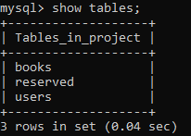

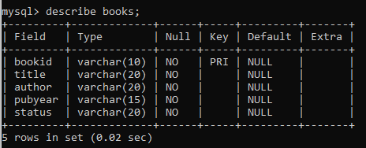

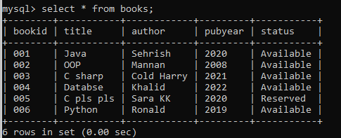

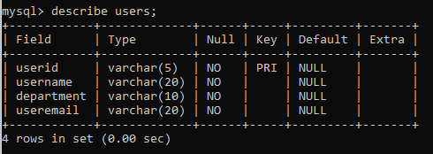

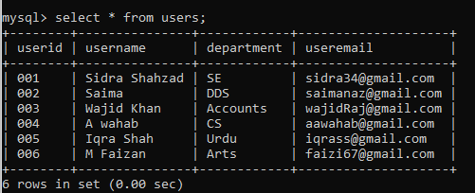

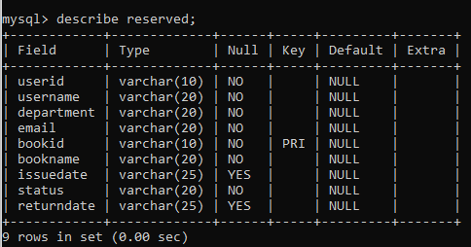

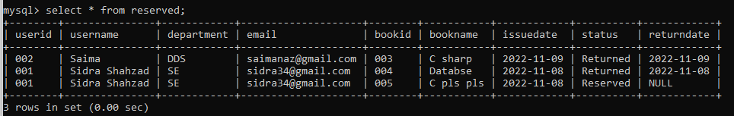

**Use Case Diagram**

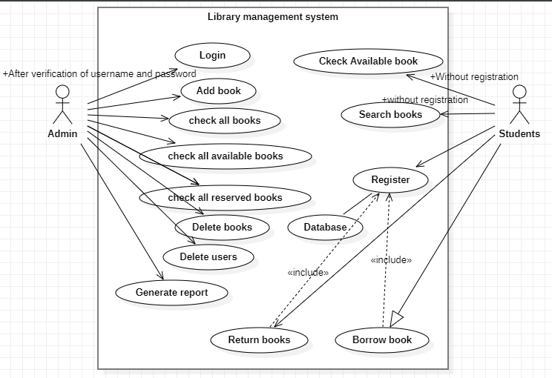

**Class Diagram**

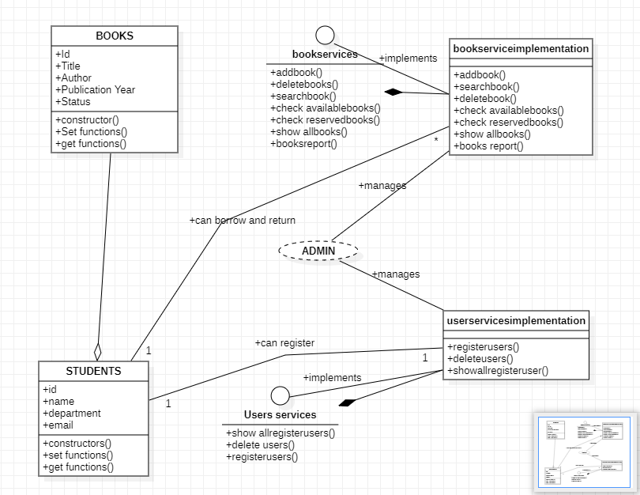

**ER Diagram**

